Exp.No-7

7. Capture video from web Camera and Display the video, in slow motion and in fast motion.

Aim:
To capture live video from the webcam using OpenCV.

Procedure:
- Start the program.
- Import the OpenCV library.
- Access the webcam.
- Capture video frames continuously.
- Display each frame.
- Press Q to stop capturing.
- Release the webcam and close all windows.
- Stop the program.
Program:
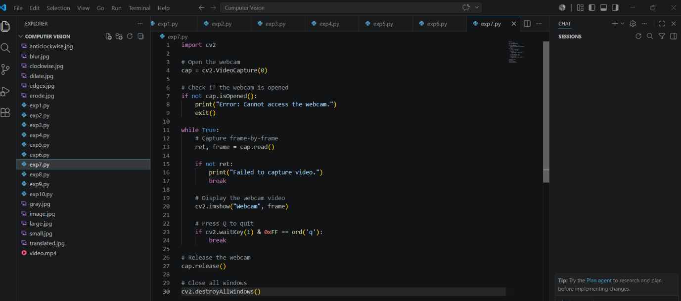

Output:
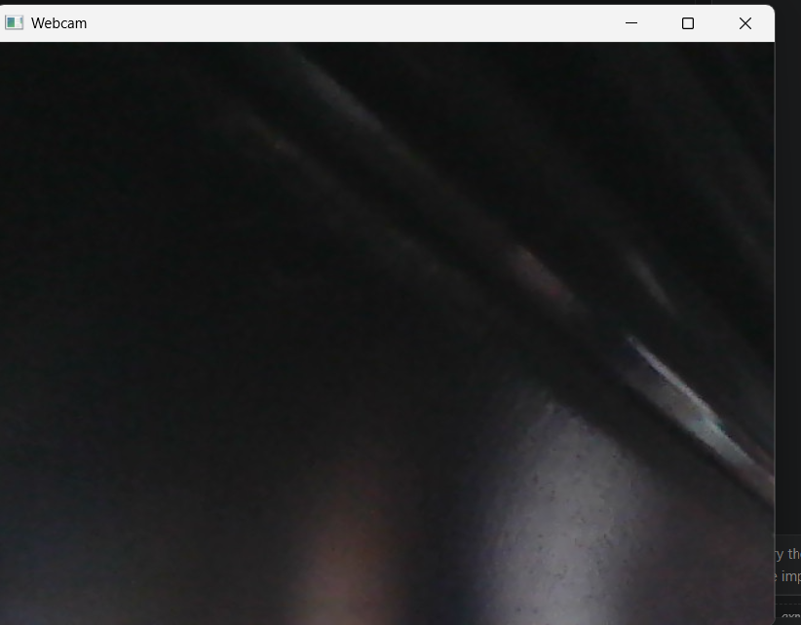

Result:
The live video from the webcam was successfully captured and displayed.

